Configuración del servidor.

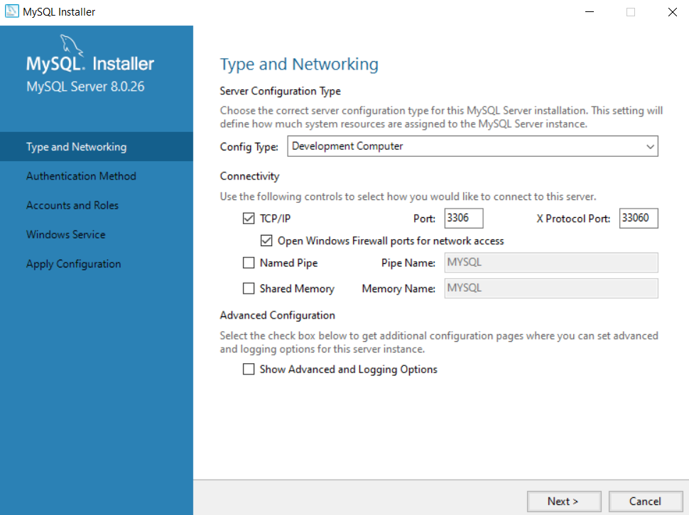

Password de Root = vill$

Servicio de mysql inicio automatico check

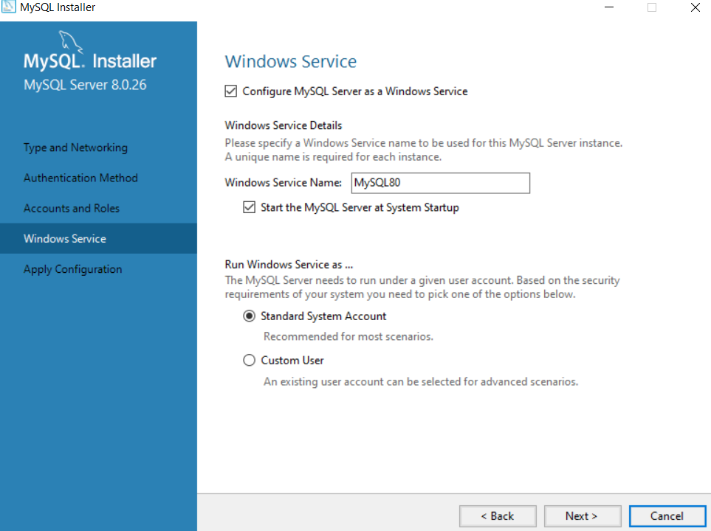

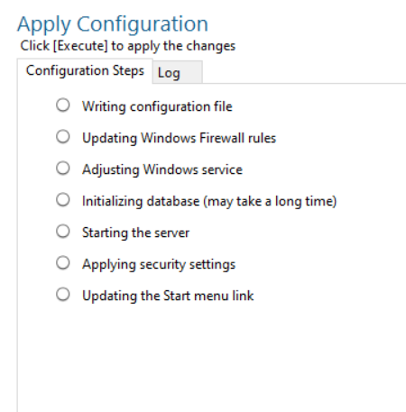

use modificar;

create table producto(

clave_prod int,

nom_prod varchar(20),

precio float,

constraint pk_cp primary key (clave_prod));

create table cliente(

clave_clie int,

nom_clie varchar(20),

constraint pk_cc primary key (clave_clie));

create table nota(

folio int,

clave_prod1 int,

clave_clie1 int,

cant int,

subtot float,

constraint fk_cp1 foreign key (clave_prod1) references producto (clave_prod),

constraint fk_cc1 foreign key (clave_clie1) references cliente (clave_clie));

insert into nota values (1,1,1,4,null);

insert into nota values (2,2,2,1,null);

select * from nota;

select* from producto;

select* from cliente;

update cliente

set nom_clie='laura'

where clave_clie=1;

update nota as n

inner join producto as p on p.clave_prod=n.clave_prod1

set n.subtot=n.cant*p.precio;

inner join en update mysql

https://stackoverflow.com/questions/8057565/mysql-update-inner-join-tables-query